Project Design Phase-II
Data Flow Diagram & User Stories

Date | 8-12-2025
Team ID | SWUID20250207937
Project Name | Social Media App (MERN)
Maximum Marks | 4 Marks

Data Flow Diagrams:
A Data Flow Diagram (DFD) illustrates how data moves within the Social Media platform. It captures how users be it interact with the system, how information flows between different components, and where the data is stored.
DFD Level 0 (Industry Standard)

DFD Level-0 is the big-picture context view: it shows your whole system as one single process and focuses on how external entities (like User/Admin) exchange data with the system.
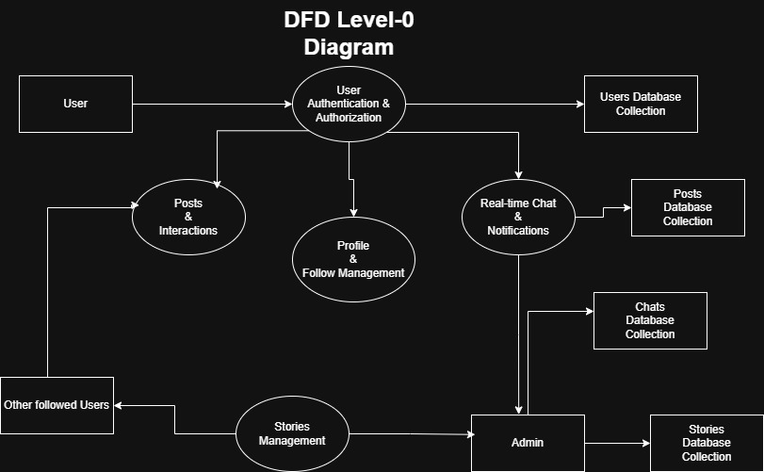

User Stories

User Story Table – Freelance Finder
User Type | Functional Requirement (Epic) | User Story / Task | Acceptance Criteria | Priority | Release
User | Authentication | As a user, I can register and login securely. | Account created; JWT issued; invalid credentials rejected. | High | Sprint-1
User | Profile | As a user, I can view and update my profile photo and bio. | Updated info persists and is visible on profile page. | High | Sprint-1
User | Follow System | As a user, I can follow/unfollow others. | Counters update; home feed reflects following list. | High | Sprint-1
User | Posts | As a user, I can create posts with text and media. | Post appears in my profile and home feed. | High | Sprint-1
User | Likes & Comments | As a user, I can like and comment on posts. | Like/comment count updates; comment list displays. | High | Sprint-1
User | Saved Posts | As a user, I can save/unsave posts. | Saved list shows correct posts per user. | Medium | Sprint-2
User | Stories | As a user, I can upload and view stories. | Story appears in stories feed; expires after 24 hours.. | High | Sprint-2
User | Messaging | As a user, I can chat with friends in real time. | Messages deliver instantly and persist in chat history. | High | Sprint-2
User | Notifications | As a user, I receive real-time notifications. | Likes/comments/follows/messages trigger notifications. | Medium | Sprint-2
User | Moderation | As an admin, I can review reports and take action. | Reports visible; actions logged; user/content status updates. | Medium | Sprint-3

